# HTML to PDF Conversion with Node.js

#### 1. Introduction:

When it comes to converting HTML content into PDF documents in Node.js applications, several libraries offer different approaches and functionalities. In this guide, we'll explore three popular options: Puppeteer, jsPDF, and PDFKit. Each library has its own strengths and weaknesses, catering to different use cases and preferences.

#### 2. Research on library or API for converting HTML to PDF

# Puppeteer

**Overview:**

* Puppeteer, developed by Google, offers a high-level API for controlling headless Chrome or Chromium browsers.
* It is the most popular choice for HTML-to-PDF conversion, supporting HTML, CSS, and JavaScript.

**Setting up:**

* Installation via npm: npm install puppeteer

**Usage:**

* Provides complete control over web page elements included in the PDF.
* Offers customization options for page size, margins, headers, and footers.
* Capable of capturing interactive elements like hyperlinks and form fields.

**Pros:**

* Complete control over PDF content.
* Customizable layout options.
* Supports interactive elements.

**Cons:**

* PDFs generated can be larger.
* Resource-intensive for complex web pages.

# jsPDF

**Overview:**

* jsPDF is a client-side JavaScript library for generating PDF files dynamically in web browsers.
* Well-maintained, easy to use, and suitable for basic PDF generation tasks.

**Setting up:**

* Include the library in HTML: <script src="https://cdnjs.cloudflare.com/ajax/libs/jspdf/2.4.0/jspdf.umd.min.js"></script>

**Usage:**

* Operates entirely on the client side, making it suitable for web applications.
* Relatively easy to use with minimal JavaScript code required.
* Integration with other JavaScript libraries and frameworks.

**Pros:**

* Client-side operation.
* Easy to use for basic tasks.
* Seamless integration with web applications.

**Cons:**

* Resource-intensive for large documents.
* Limited advanced features.

# PDFKit

**Overview:**

* PDFKit is a server-side PDF generation library for Node.js, offering fine-grained control over PDF content, layout, and formatting.
* Suitable for creating highly customized PDFs dynamically.

**Setting up:**

* Installation via npm: npm install pdfkit

**Usage:**

* Provides extensive control over PDF document creation.
* Great for generating PDFs dynamically in server-side environments.
* Open source with active community support.

**Pros:**

* Fine-grained control over PDF content.
* Ideal for server-side PDF generation.
* Actively maintained with community support.

**Cons:**

* Steeper learning curve for complex documents.
* Requires manual control over document structure.

**Feature Comparison**

| **Feature** | **Puppeteer** | **jsPDF** | **PDFKit** |
| --- | --- | --- | --- |
| PDF generation | HTML and web page content | HTML and SVG content | PDF creation from scratch |
| File size | No control | No control | Control over file size |
| Browser integration | Headless Chrome integration | No browser integration | No browser integration |
| Community support | Active community support and updates | Active community support and updates | Active community support and updates |

In summary, Puppeteer is ideal for scenarios requiring precise control over PDF content and layout, while jsPDF suits basic client-side PDF generation tasks. On the other hand, PDFKit is perfect for complex server-side PDF generation needs. We can choose the library that best aligns with your project requirements and development expertise.

## Using Commercial APIs:

# DocRaptor:

**Pros**: Highly accurate rendering, robust handling of modern CSS and JavaScript, reliable cloud service, API and SDKs.

**Cons**: Paid service, may not be cost-effective for low-volume use.

PDFShift:

**Pros:** Cloud-based, fast processing, good rendering quality, API and SDKs.

**Cons**: Paid service, pricing may vary depending on usage.

wkhtmltopdf Cloud:

**Pros:** Web interface for easy conversion, API access.

**Cons**: May be slower than other paid options, pricing based on usage.

#### 3.Choosing the Right Library/API:

Consider these factors:

* **Complexity of web pages:**
  + **Puppeteer, WeasyPrint, or DocRaptor:** for intricate layouts.
  + **jsPDF or simpler open-source libraries:** for basic pages.
* **Control and customization:**
  + **Open-source libraries:** offer more control over formatting.
  + **APIs:** simplify the process.
* **Resource constraints:**
  + **jsPDF or pdf-lib:** lightweight options for CPU/memory limitations.
* **Development environment:**
  + Choose libraries compatible with your programming language.
* **Budget:**
  + **Open-source options:** free.
  + **Commercial APIs:** wider features and support, but require payment.

#### 4.User Guide:

**How to Use:**

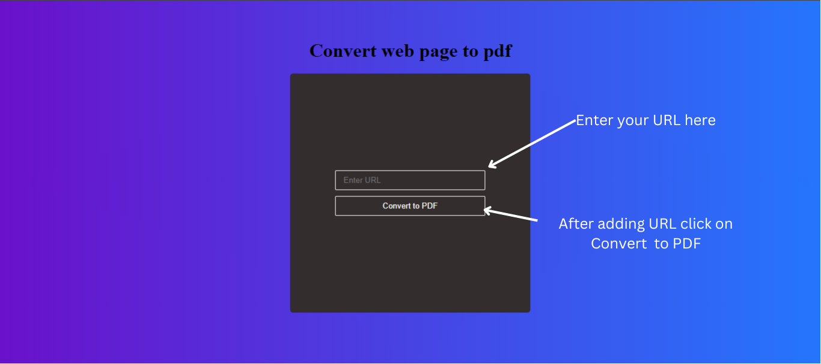

1. Enter the URL of the web page you want to convert to PDF into the input field.
2. Click on the "Convert to PDF" button.
3. Wait for the PDF generation process to complete.
4. Once the PDF is generated, it will automatically download to your device.
5. Locate the downloaded PDF file in your downloads folder or the specified download location.

#### 5.conclusion:

In summary, Puppeteer provides developers with robust control over HTML-to-PDF conversion, offering customization options for layout and interactive elements. While it may lead to larger file sizes and resource-intensive processing for complex pages, its advantages outweigh these drawbacks. Leveraging Puppeteer ensures efficient and user-friendly PDF generation in web applications.

#### 6. References:

* <https://blog.logrocket.com/best-html-pdf-libraries-node-js/>
* <https://medium.com/coderbyte/generate-a-pdf-with-javascript-3e53ca7b47e>
* <https://blog.risingstack.com/pdf-from-html-node-js-puppeteer/>
* <https://www.bannerbear.com/blog/how-to-convert-html-into-pdf-with-node-js-and-puppeteer/>
* <https://www.npmjs.com/package/pdf-puppeteer>